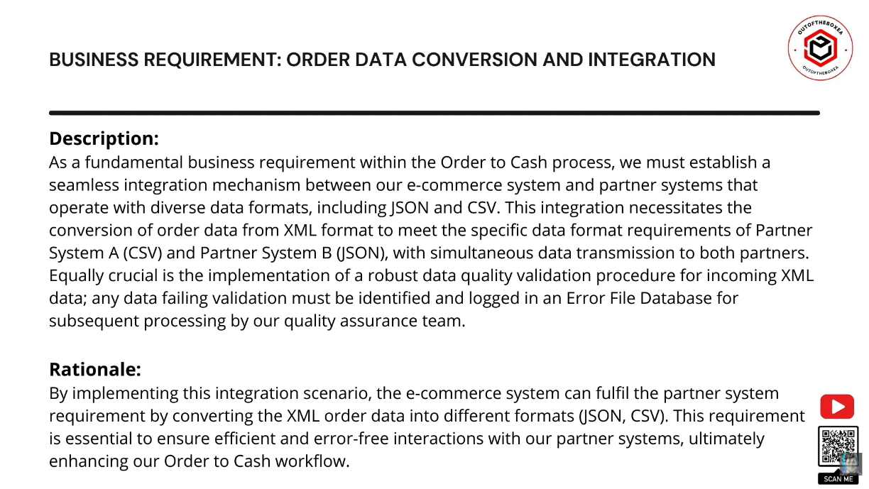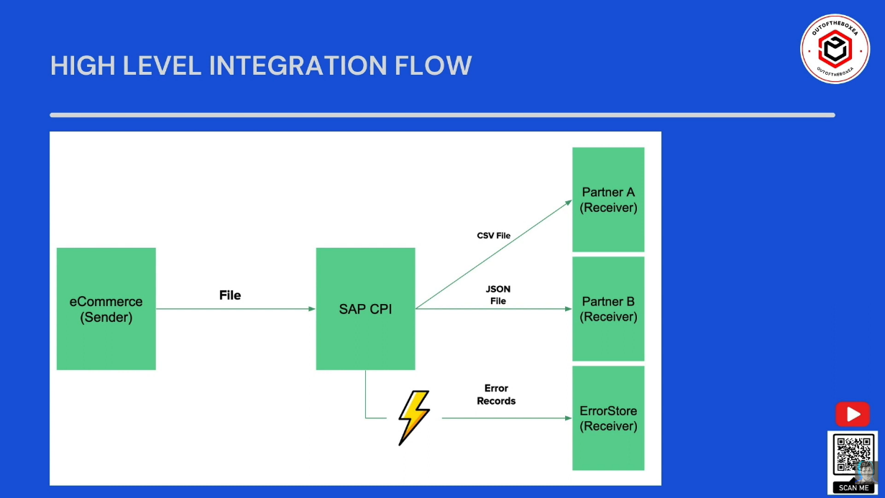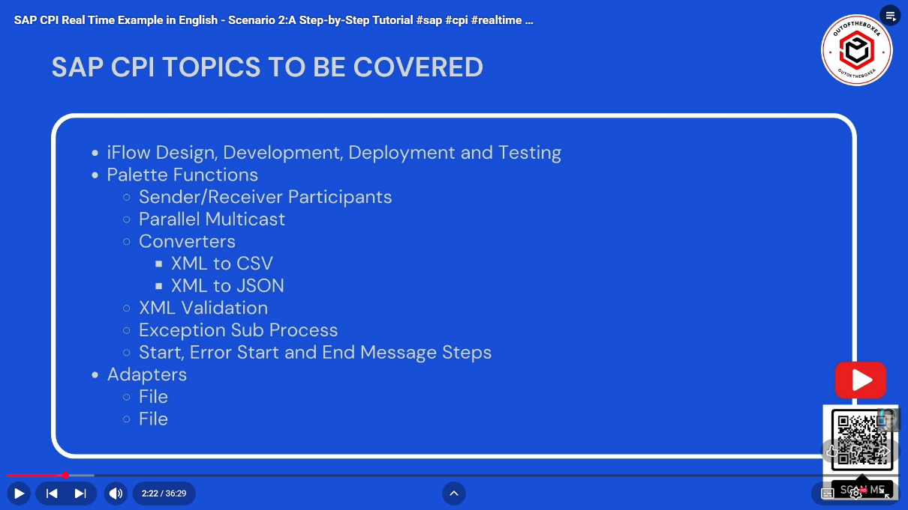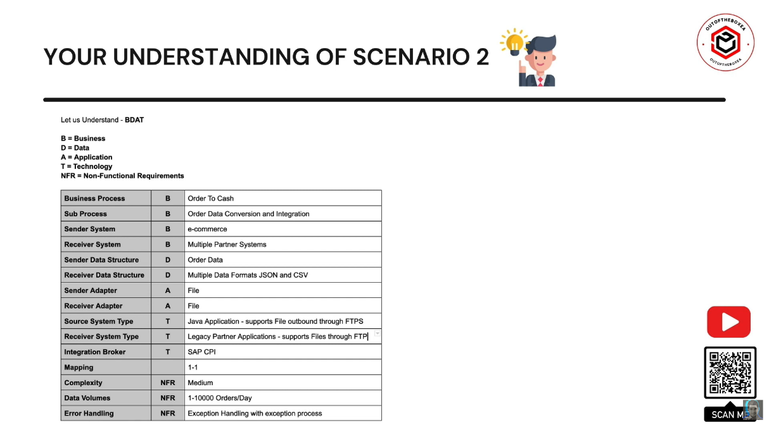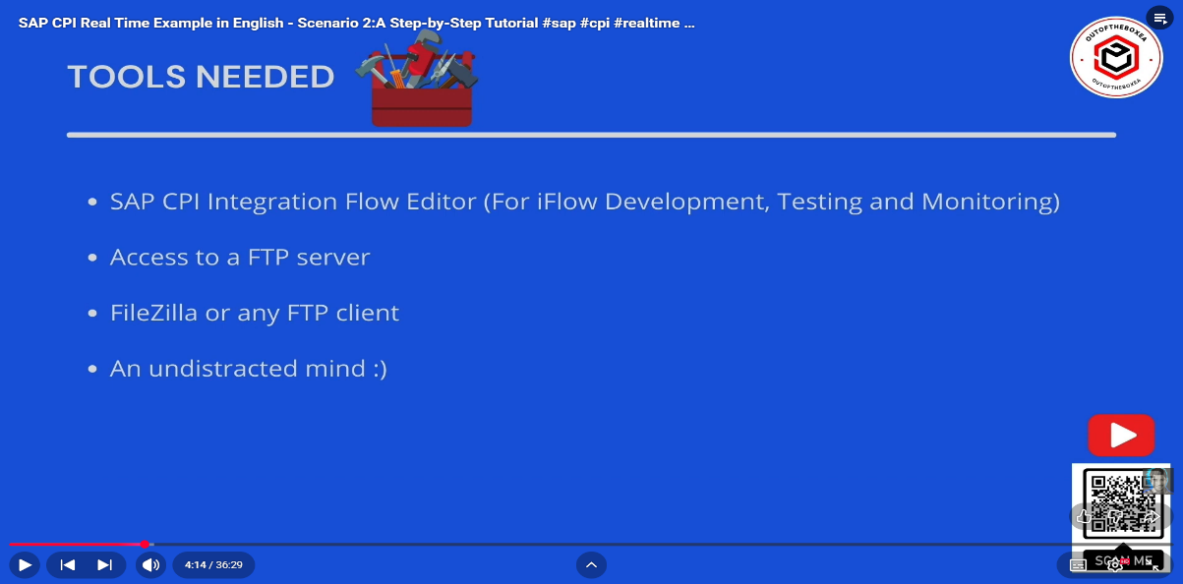

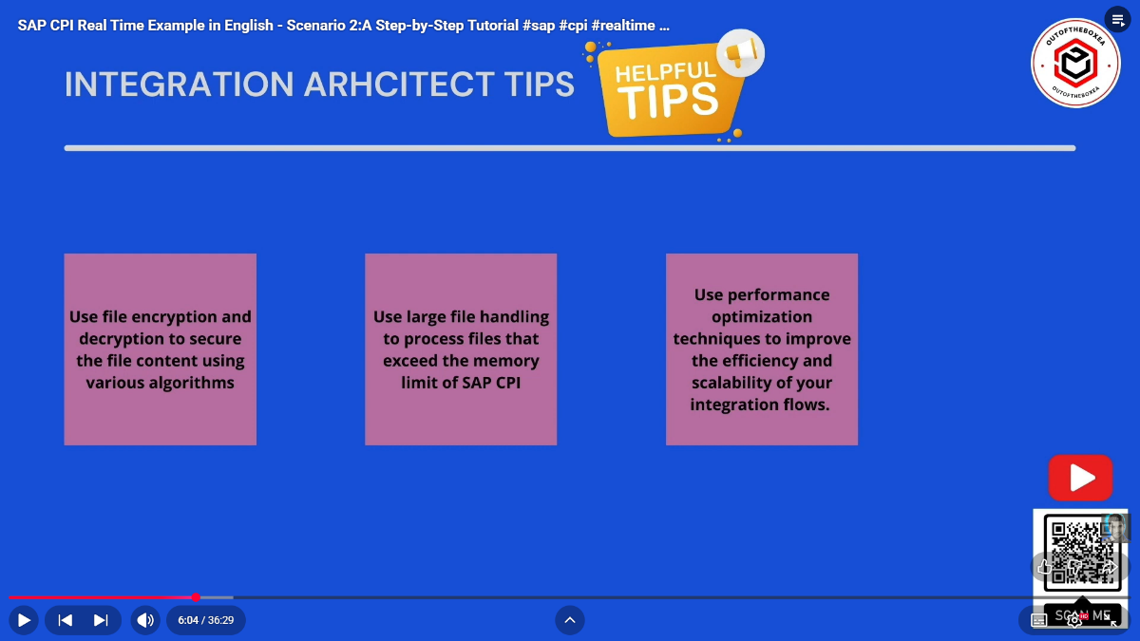

🔹 Interview Question (Very Common)
Q: Can you directly upload an Integration Flow file in SAP CPI?
👉 Answer:
No. Integration Flows must be uploaded as part of an Integration Package (ZIP file). SAP CPI does not support direct single iFlow uploads.

⭐ Interview Tip (Bonus)
Always mention Monitoring, Security, and Performance
Interviewers expect real-time operational thinking, not just configuration steps.
⭐ One-Line Interview Answer
XSLT mapping in SAP CPI is used to efficiently transform XML data with better performance and streaming support, especially for large and complex payloads.

⭐ One-Line Interview Answer
CDATA is used in XML to include special characters or raw text without being parsed as XML, commonly used in SAP CPI to avoid XML validation errors.
⭐ One-Line Interview Answer
PGP Encryption in SAP CPI is used to secure files by encrypting data with the receiver’s public key, ensuring confidentiality and compliance during file transfer.
⭐ One-Line Interview Answer
Public key is used for encryption and can be shared, while private key is used for decryption and must be kept secret; together they enable secure communication.
⭐ One-Line Summary
SSH is a secure protocol that encrypts communication and is mainly used in SAP CPI with SFTP for secure file transfer using key-based authentication.
🎯 Interview One-Liners
- What is SSH?
👉 Secure protocol for encrypted communication
- Which adapter uses SSH in CPI?
👉 SFTP Adapter
- Best authentication method?
👉 Key-based authentication

⭐ One-Line Interview Answer

FTP is unsecured, SFTP uses SSH encryption, and FTPS uses SSL/TLS; in SAP CPI, SFTP is the preferred and most secure option.

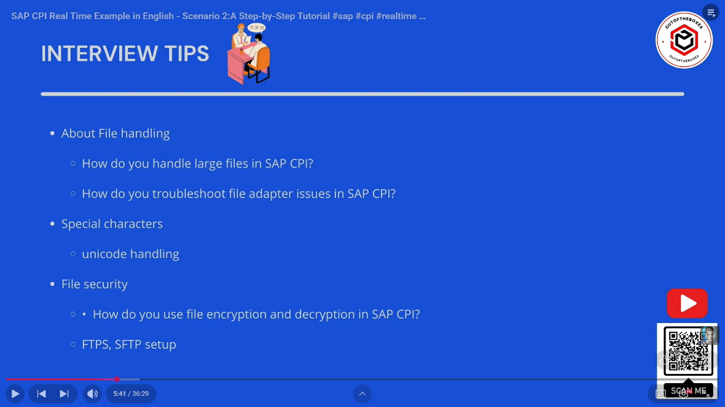

1️⃣ How do you handle large files in SAP CPI?
Answer:
- Use streaming approach instead of loading full file into memory
- Enable Streaming in File / SFTP adapter (if supported)
- Split large files using:
  - General Splitter
  - Iterating Splitter
- Process data in chunks (batch processing)
- Avoid unnecessary message mappings on very large payloads
- Use Content Modifier only when required
- Monitor memory usage via Message Processing Logs
- Prefer XSLT mapping over graphical mapping for performance
- Archive files externally after processing to reduce load

2️⃣ How do you troubleshoot File Adapter issues in SAP CPI?
Answer:
Step-by-step approach:
- Check Message Monitoring in CPI cockpit
- Open Failed Message → view Error Details
- Verify Directory path (case-sensitive)
- Check File permissions (read/write)
- Validate File name pattern
- Ensure correct Polling interval
- Confirm Credentials in Security Material
- Check Processing mode (Pick up & Delete / Archive)
- Review MPL (Message Processing Log)
- Test adapter connection using Test Connection

3️⃣ How do you handle special characters in SAP CPI?
Answer:
- Ensure UTF-8 encoding is used
- Avoid hardcoding special characters in mappings
- Use CDATA section for XML when needed
- Use Escape characters in Groovy scripts
- In message mapping:
  - Enable Suppress XML Validation if required
- Validate payload using XML Validator
- Avoid manual string concatenation for XML

4️⃣ What is Unicode handling in SAP CPI?
Answer:
- SAP CPI supports Unicode (UTF-8) by default
- Unicode allows processing:
  - Special characters (€, ₹, é, ñ)
  - Multiple languages
- Ensure:
  - Sender system sends UTF-8 encoded data
  - Receiver adapter expects UTF-8
- Use Content-Type = application/xml; charset=UTF-8
- Prevent data corruption during transformations

5️⃣ How do you use file encryption & decryption in SAP CPI?
Answer:
🔐 Encryption:
- Use PGP Encryption
- Upload Public Key in:
  - Security Material → PGP Keys
- Configure PGP Encryptor step
- Used to secure data before sending to receiver
🔓 Decryption:
- Upload Private Key in Security Material
- Configure PGP Decryptor step
- Used to decrypt incoming encrypted files
Why used?
- Data security
- Compliance (GDPR, ISO)
- Secure file transfer

6️⃣ How do you set up FTPS / SFTP in SAP CPI?
🔹 SFTP Setup:
- Use SFTP Adapter
- Configure:
  - Host
  - Port (default 22)
  - Username
- Upload SSH Private Key in Security Material
- Select Key-based authentication
- Test connection
🔹 FTPS Setup:
- Use FTP Adapter
- Enable FTPS (Explicit / Implicit)
- Upload X.509 certificate
- Configure:
  - Port (21 / 990)
  - Encryption mode
- Enable TLS/SSL

⭐ Interview Tip (Bonus)
Always mention Monitoring, Security, and Performance
Interviewers expect real-time operational thinking, not just configuration steps.

If you want:
- 📘 Short exam notes
- 🎯 1–2 line interview answers
- 💬 Mock interview Q&A
- 📝 PDF notes for SAP CPI File Handling
Just tell me 👍
xslt mapping
Below is a clear, interview-ready explanation of XSLT Mapping in SAP CPI, written point-wise (as you prefer) and with practical + interview focus 👇

🔹 What is XSLT Mapping in SAP CPI?
- XSLT (Extensible Stylesheet Language Transformations) is used to:
  - Transform XML → XML
  - Convert source XML structure into target XML structure
- In SAP CPI, XSLT is used as a Mapping Step in Integration Flows

🔹 Why use XSLT mapping in SAP CPI?
- Better performance for large payloads
- Supports streaming
- More control than graphical message mapping
- Ideal for:
  - Large files
  - Complex conditional logic
  - Looping and grouping
- Faster execution and less memory usage

🔹 XSLT vs Message Mapping (Interview Question)
Feature | XSLT Mapping | Message Mapping
Performance | ✅ High | ❌ Medium
Large files | ✅ Best choice | ❌ Memory heavy
Streaming | ✅ Supported | ❌ Not supported
Ease of use | ❌ Needs coding | ✅ Drag & drop
Complex logic | ✅ Easy | ❌ Difficult

🔹 How to create XSLT mapping in SAP CPI?
Steps:
- Open Integration Flow
- Add Mapping step
- Select XSLT Mapping
- Upload or paste XSLT code
- Save and deploy

🔹 Simple XSLT Example (SAP CPI)
🔸 Source XML
<Employees>
<Employee>
<ID>101</ID>
<Name>Avdhut</Name>
</Employee>
</Employees>
🔸 Target XML
<Staff>
<StaffMember>
<StaffID>101</StaffID>
<StaffName>Avdhut</StaffName>
</StaffMember>
</Staff>
🔸 XSLT Code
<xsl:stylesheet version="1.0"
xmlns:xsl="http://www.w3.org/1999/XSL/Transform">

<xsl:template match="/">
<Staff>
<xsl:for-each select="Employees/Employee">
<StaffMember>
<StaffID>
<xsl:value-of select="ID"/>
</StaffID>
<StaffName>
<xsl:value-of select="Name"/>
</StaffName>
</StaffMember>
</xsl:for-each>
</Staff>
</xsl:template>

</xsl:stylesheet>

🔹 Common XSLT functions used in SAP CPI
- xsl:value-of → read value
- xsl:for-each → loop
- xsl:if → condition
- xsl:choose / when / otherwise → if-else
- concat() → combine strings
- substring() → string extraction
- normalize-space() → trim spaces

🔹 Handling conditions in XSLT
<xsl:if test="Salary &gt; 50000">
<Grade>Senior</Grade>
</xsl:if>

🔹 Error handling in XSLT (Interview Tip)
- Validate input XML before mapping
- Avoid hardcoded namespaces
- Handle missing fields using:
<xsl:if test="Name">
- Check errors in Message Processing Log

🔹 When should you prefer XSLT in SAP CPI?
- Large XML files
- Performance-critical integrations
- Streaming requirement
- Complex transformations
- File-based integrations

⭐ One-Line Interview Answer
XSLT mapping in SAP CPI is used to efficiently transform XML data with better performance and streaming support, especially for large and complex payloads.

If you want next:
- ✅ Real-time SAP CPI XSLT scenario
- ✅ XSLT vs Groovy comparison
- ✅ Interview questions on XSLT
- ✅ Common XSLT errors & fixes
Just tell me 👍
CDATA section for XML
Below is a clear, interview-ready explanation of CDATA in XML, written point-wise and SAP CPI focused 👇

🔹 What is a CDATA section in XML?
- CDATA (Character Data) is used to include text that should NOT be parsed as XML
- XML parser treats CDATA content as plain text
- Special characters inside CDATA are not interpreted as XML tags

🔹 Syntax of CDATA
<![CDATA[
text here
]]>

🔹 Why do we use CDATA?
- To avoid XML parsing errors
- To handle special characters safely:
  - < > & ' "
- To embed:
  - HTML
  - SQL queries
  - Scripts
  - Special messages

🔹 Example without CDATA (Error-prone)
<Message>
<Text>Price is < 100 & valid</Text>
</Message>
❌ Causes XML parsing error

🔹 Example with CDATA (Correct)
<Message>
<Text><![CDATA[Price is < 100 & valid]]></Text>
</Message>
✅ XML parses successfully

🔹 CDATA in SAP CPI (Real-Time Use)
Used when:
- Receiver system expects raw text
- Payload contains:
  - HTML body
  - Error messages
  - Special characters
- Avoid escaping characters in mappings

🔹 CDATA in XSLT Mapping (Very Important)
Example:
<xsl:template match="/">
<Output>
<Message>
<![CDATA[
This is <test> & special characters
]]>
</Message>
</Output>
</xsl:template>

🔹 CDATA vs Escaping characters (Interview Question)
CDATA | Escaping
Easy to read | Hard to read
Handles large text | Needs multiple escapes
No parsing | Parser interprets escapes
Escaping example:
&lt; &gt; &amp;

🔹 Important rules of CDATA
- CDATA cannot contain ]]>
- Cannot be nested
- Only for text, not XML elements
- Overuse is not recommended

🔹 Common interview question
Q: Does CDATA improve performance?
👉 No, it only prevents XML parsing of characters.

⭐ One-Line Interview Answer
CDATA is used in XML to include special characters or raw text without being parsed as XML, commonly used in SAP CPI to avoid XML validation errors.

If you want next:
- 🔁 CDATA in Groovy script
- 🧩 CDATA in Message Mapping
- ❌ Common CDATA mistakes
- 🎯 Interview Q&A on XML handling
Just tell me 👍
PGP Encryption
Below is a clear, interview-ready explanation of PGP Encryption in SAP CPI, written point-wise, simple, and practical 👇

🔐 What is PGP Encryption?
- PGP (Pretty Good Privacy) is used to secure files/data
- It ensures:
  - Confidentiality (data is unreadable)
  - Security during transmission
- Widely used in file-based integrations

🔹 Why is PGP Encryption used in SAP CPI?
- To protect sensitive business data
- Mandatory for:
  - Banking
  - Healthcare
  - Payroll
- Ensures data is encrypted before sending to receiver
- Only receiver with private key can decrypt

🔑 PGP Key Concept (Interview Must-Know)
Key Type | Used For
Public Key | Encryption
Private Key | Decryption
Passphrase | Protects private key

🔹 PGP Encryption Flow in SAP CPI
- Sender sends plain file
- SAP CPI encrypts file using receiver’s public key
- Encrypted file is sent to receiver
- Receiver decrypts using private key

🔹 How to configure PGP Encryption in SAP CPI?
✅ Step-by-Step:
- Go to Security Material
- Upload PGP Public Key
  - Type: PGP Key
  - Alias name
- Open Integration Flow
- Add PGP Encryptor step
- Configure:
  - Public key alias
  - Encryption algorithm
- Deploy iFlow

🔹 How to configure PGP Decryption?
✅ Steps:
- Upload PGP Private Key in Security Material
- Provide Passphrase
- Add PGP Decryptor step
- Configure key alias
- Deploy

🔹 PGP Algorithms supported in SAP CPI
- RSA
- AES (128 / 256)
- SHA-1 / SHA-256 (for hashing)

🔹 PGP Encryption vs SSL/TLS (Interview Question)
PGP | SSL/TLS
File-level security | Transport-level security
End-to-end encryption | Secures communication channel
Used for batch files | Used for real-time APIs

🔹 Common PGP issues in SAP CPI
- ❌ Wrong key alias
- ❌ Public key expired
- ❌ Passphrase mismatch
- ❌ Using private key for encryption
- ❌ Character encoding mismatch
👉 Check Message Processing Logs for errors

🔹 Best Practices
- Use key rotation
- Protect private keys strictly
- Do not hardcode passphrases
- Use strong algorithms
- Test encryption before go-live

⭐ One-Line Interview Answer
PGP Encryption in SAP CPI is used to secure files by encrypting data with the receiver’s public key, ensuring confidentiality and compliance during file transfer.

